IDEATION PHASE – 2. DEFINE PROBLEM STATEMENT
Date | 8/10/2026
Team ID | 9100Orbit
Project Name | Implement Client Script & UI Policy (Incident)
Maximum Marks | 4 Marks

Problem Definition
The problem statement is defined from the Incident-management problem described in the uploaded project document.

Existing Problem
Incident records often require consistent and accurate data entry to ensure effective triage, routing, and resolution. However, relying solely on user awareness and manual checks can lead to incomplete, inconsistent, or incorrect data being submitted. This can impact reporting accuracy, SLA compliance, and overall service quality.

Who is affected?
Stakeholder | Need / Impact
Incident users / service desk staff | Need clear and guided form behavior while entering Incident information.
Incident managers / administrators | Need consistent Incident records that follow defined business rules.
Reporting / SLA stakeholders | Depend on complete and accurate Incident data.

Problem Statement
How might we ensure that Incident records are complete, consistent, and valid by dynamically controlling field behavior and validating user input at the ServiceNow interface level, especially for High Impact Incidents?

Root Causes Identified
- Dependence on manual user awareness and checks.
- Fields may be left incomplete or entered inconsistently.
- High-impact Incidents require additional controls.
- Users may attempt direct list editing of State.
- Validation is required before an Incident is saved.

Desired Outcome
The solution should dynamically make required fields mandatory, control field behavior, automatically update values when conditions are met, and prevent invalid Incident records from being submitted.
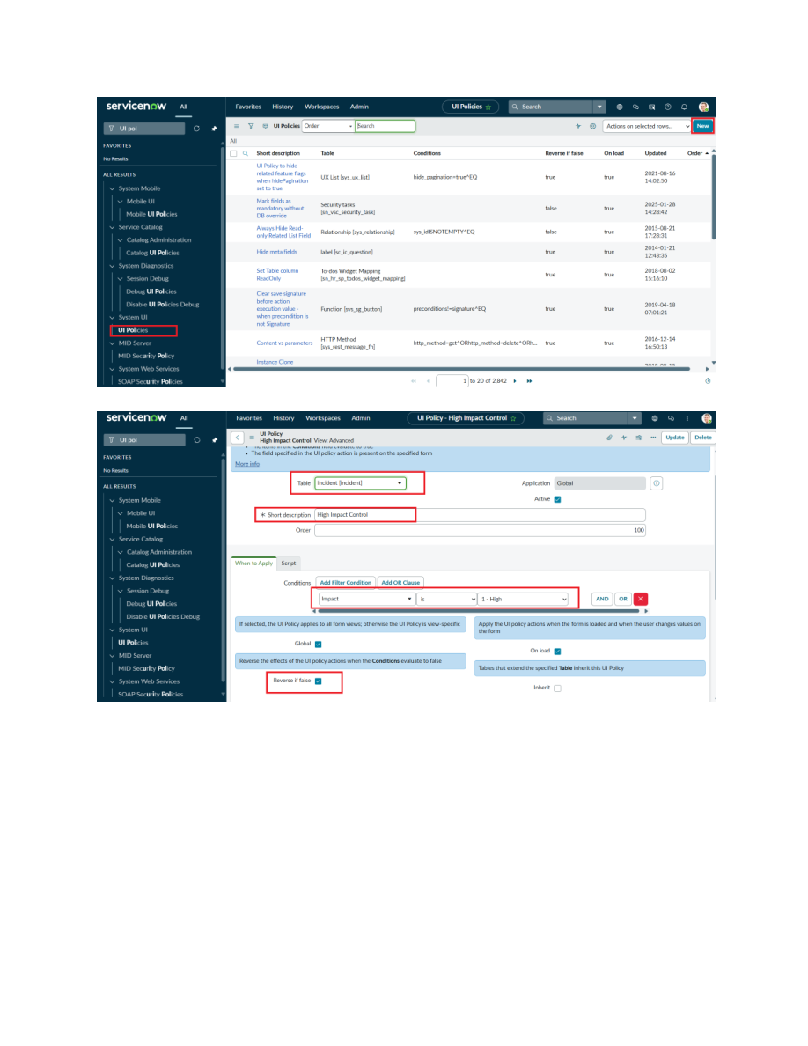
Figure 1. UI Policy condition for Impact = 1 – High from the uploaded project PDF.
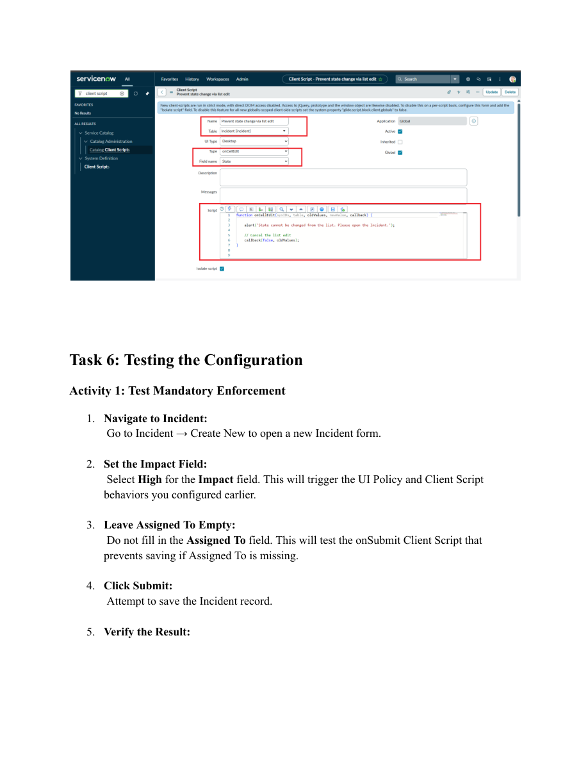
Figure 2. Mandatory enforcement test from the uploaded project PDF.

Project Objective
The objective is to demonstrate how ServiceNow client-side controls can be used to enforce data integrity on Incident records by making fields mandatory, auto-populating values, controlling field behavior, and preventing record submission when required conditions are not met.

Proposed Solution
Requirement | Proposed ServiceNow Control | Expected Result
High Impact control | UI Policy: High Impact Control | Applies additional controls when Impact is High.
Assignment Group requirement | UI Policy Action | Assignment Group becomes mandatory.
Urgency automation | onChange Client Script | Urgency is set to High for High Impact.
Assigned To validation | onSubmit Client Script | Save is prevented when Assigned To is empty for High Impact.
State list-edit restriction | onCellEdit Client Script | Direct State changes through list editing are blocked.
Reverse behavior | Reverse if false | UI Policy changes are reverted when condition is false.

